QTec® – Reinventing optical vibration measurement

QTec® makes the difference. A revolutionary technology makes vibration measurements faster, easier and more reliable than ever - for the most robust, unambiguous results. QTec® represents a new quality in non-contact vibration measurements on engineered surfaces, utilizing the very last quantum of light for high-fidelity data under all conditions. QTec® is designed to give simply the best Signal to Noise ratio (SNR) ever, especially for laterally moving or rotating objects, long distant or biological samples.
What drives the additional performance of QTec®? As with the other members of the VibroFlex family QTec® uses a low noise class 2 laser, which can be used safely without eye protection. The performance gains are achieved by a patented arrangement of multiple detection channels that combine the best reading from the sample for a consistent result. The significance is a signal that is always stable, the signal to noise ratio is notably higher with clear results facilitating interpretation and post-processing.
How does QTec® add value to vibration testing? A lower noise floor with better SNR improves results, saves time and uncovers small peaks that were previously obscured. QTec® provides clear spectra on dark, rotating or moving surfaces, keeping track of every photon and thus guarantees continuous time signals under all conditions. The QTec® sensor head is the new flagship of the VibroFlex Vibrometer range. Deployment is simple and flexible as it integrates seamlessly with the existing digital front-ends of the VibroFlex series. VibroFlex QTec® is the best choice for all engineered surfaces.

Find further information here: https://www.polytec.com/us/vibrometry/technology/qtec
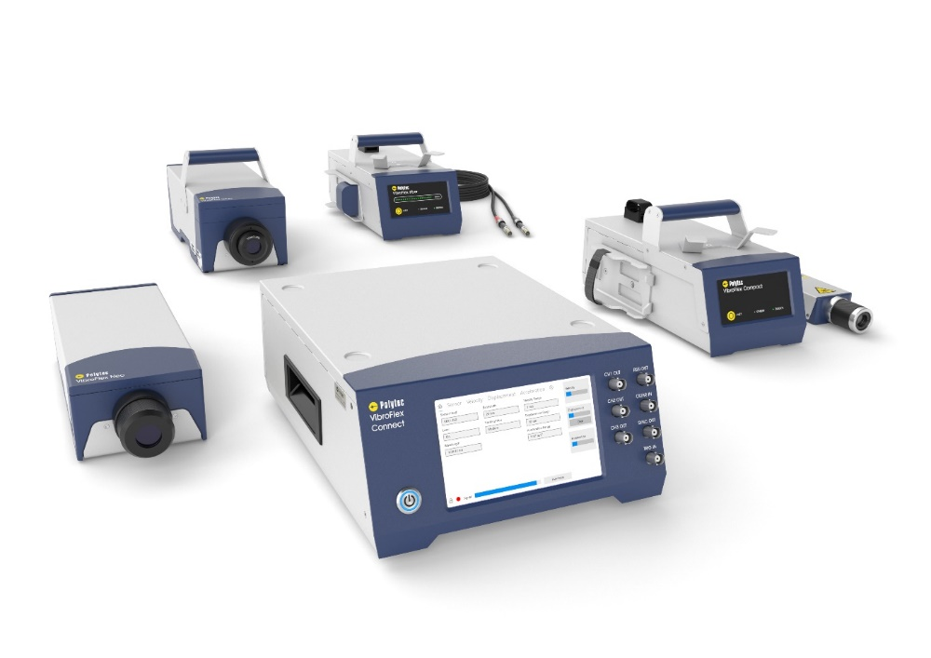
Pic. 1: The new member of the VibroFlex Family

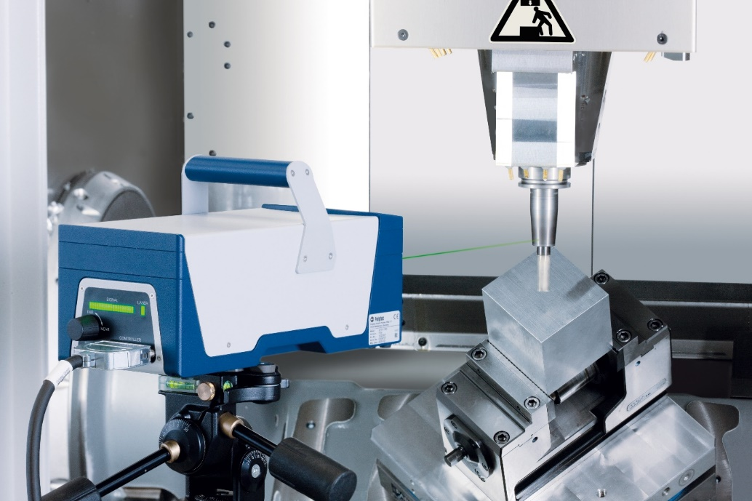
Pic. 2: Direct measurement on rotating parts – QTec in action

